Practice Set: Visual Inspection of Plots

1. **Income and time to first child**: The dataset [incomebirth.txt](https://onlinecourses.science.psu.edu/stat501/sites/onlinecourses.science.psu.edu.stat501/files/data/incomebirth.txt) contains husband’s annual incomes ($inc$, in dollars) and time ($time$, in months) between marriage and first child for $n=20$ couples. (As you can tell by the incomes, the data set is rather old!)
   1. Create a fitted line plot treating $time$ as the response and $inc$ as the predictor.
   2. Looking at the plot, is a linear function adequate in describing the relationship between $inc$ and $time$? Explain your answer.
2. **Bluegill fish**: The data set [bluegills.txt](https://onlinecourses.science.psu.edu/stat501/sites/onlinecourses.science.psu.edu.stat501/files/data/bluegills.txt) contains the lengths (in $mm$) and ages (in $years$) of $n=78$ bluegill fish.
   1. Create a fitted line plot treating $length$ as the response and $age$ as the predictor.
   2. Looking at the plot, is a linear function adequate in describing the relationship between $age$ and $length$? Explain your answer.
3. **Gesell Adaptive Scores**: The data set [adaptive.txt](https://onlinecourses.science.psu.edu/stat501/sites/onlinecourses.science.psu.edu.stat501/files/data/adaptive.txt) contains the Gesell adaptive scores and ages (in $months$) of $n=21$ children with cyanotic heart disease.
   1. Create a fitted line plot treating $score$ as the response and $age$ as the predictor.
   2. Looking at the plot, is a linear function adequate in describing the relationship between $age$ and s $core$? Explain your answer.

# Answers

1. No, the data displays a curvilinear relationship between $Y=time$ and $X=inc$.

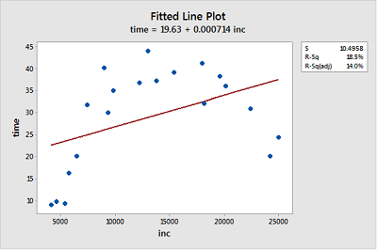

1. Probably not, because the growth pattern seems steeper than the fitted line for ages 1-4 and then length seems to level out for ages 5-6.

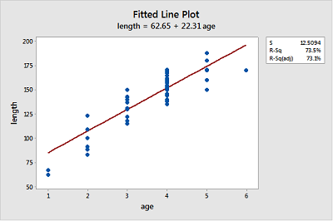

1. The linear function describes the relationship reasonably well for most of the data points, but seems strongly influenced by the point for $age=42$ at the far right and the point with $score=120$ at the top of the does not seem to fit the overall trend very well.

